Peel Common Primary Art Overview 26/27 cycle
 | Autumn 1 | Autumn 2 | Spring 1 | Spring 2 | Summer 1 | Summer 2
EYFS  Year R | Who am I?  Skills focus: drawing/painting – representative mark making, collage  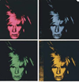  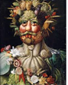  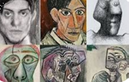  Artist/s Picasso, (Warhol), Arcimboldo | How do we celebrate?  Skills focus: Patterns, textures and colour  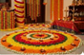  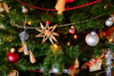  Artist: (Christmas/Diwali decorations) | What happens?  Skills focus: Mixed media – experimentation  Artist: Jackson Pollack, Lee Krasner, Gerhard Richter  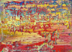  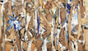  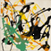 | Who helps us?  Skills focus: collaborative & printing  Artist: Thomas Yang    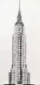 | How does it grow?  Skills focus: Drawing/painting  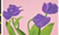  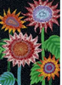  Artist: Yayoi Kusama, Alex Katz | Where do we live?  Skills focus: Sculpture  Artist/s: What is an architect?  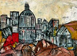  Leonardo Ribeiro
KS1  Years 1 & 2 | Natural sculptures  Skills focus:  Sculpture/collage (natural materials and textures)  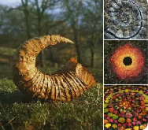  Artist: Andrew Goldsworthy |  |  |  | Flowers  Skills focus: drawing, painting and mixed media  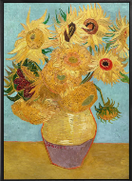  Artist: Van Gogh | Fire of London  Skills focus: Textiles/  Collage  Artist/s: Assorted Fire of London paintings,  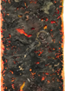  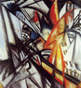  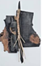  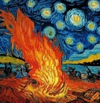  Fire inspired works; Van Gogh, Olga Rozanova, Deborah Weir, Ann Goddard
LKS2  Years 3 & 4 | Mini-beasts  Skills focus: Drawing & Painting (collage) Artist:  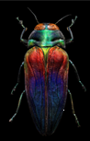  Levon Biss | Islands  Skills focus:  Textiles (collage/sculpture)  Artist/s:  Alexandra Kehayoglou  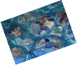  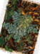  Carolyn Saxby | Reuse, Recycle  Skills focus:  Printing (painting/ collage)  Artist/s:  Mary Ellen Croteau  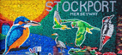    Caitlin Atherton | Mini-Art | Mini-Art | Mini-Art
UKS2  Years 5 & 6 | Rousseau  Skills focus:  Drawing & Painting (collage)  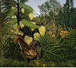  Artist: Rousseau | Mini-Art | UK Landmarks  Skills focus: Sculpture  Artist/s:  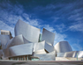  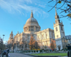  Global architects  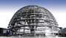  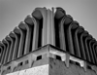  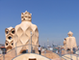 | Mini-Art | Light & Shadow  Skills focus: Painting (collage) Artists: Caravaggio Georges de La tour Lourry Legarde  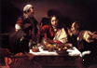  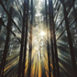  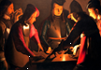 | Mini-Art

