Peel Common Primary Art Overview 25/26 cycle
 | Autumn 1 | Autumn 2 | Spring 1 | Spring 2 | Summer 1 | Summer 2
EYFS  Year R | Who am I?  Skills focus: drawing/painting – representative mark making, collage  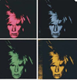  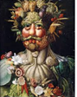  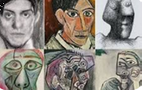  Artist/s Picasso, (Warhol), Arcimboldo | How do we celebrate?  Skills focus: Patterns, textures and colour  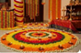  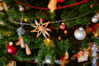  Artist: (Christmas/Diwali decorations) | What happens?  Skills focus: Mixed media – experimentation  Artist: Jackson Pollack, Lee Krasner, Gerhard Richter  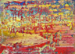  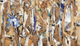  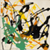 | Who helps us?  Skills focus: collaborative & printing  Artist: Thomas Yang    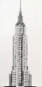 | How does it grow?  Skills focus: Drawing/painting  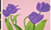  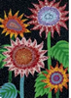  Artist: Yayoi Kusama, Alex Katz | Where do we live?  Skills focus: Sculpture  Artist/s: What is an architect?  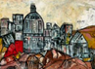  Leonardo Ribeiro
KS1  Years 1 & 2 | Seasons  Skills focus: Printing  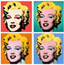  Artist:: Andy Warhol | Mini-Art Continuous provision | Mini-Art  Continuous provision | Under the Sea  Skills focus: Sculpture (clay), Drawing  Artist/s: Aude Bourgine, Marc Quinn  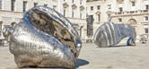  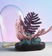 | Landscapes  Skills focus: Painting & Collage  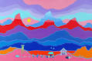  Artist/s: Ted Harrison | Mini-Art  Continuous provision
LKS2  Years 3 & 4 | Weaving – My Story  Skills focus: Textiles  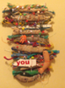  Artist: Jo Atherton | Mini-Art | Animals in 3-D  Skills focus: Sculpture, drawing  Artist/s:  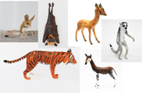  Abigail Brown | Mini-Art | Flowers  Skills focus: Drawing & Painting  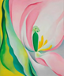  Artist/s: Georgia O’Keefe | Mini-Art
UKS2  Years 5 & 6 | Space  Skills focus: Painting &  Collage  Artist: Peter Thorpe  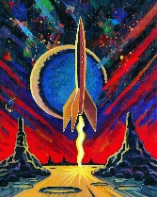 | Mini-Art | Collagraphs  Skills focus: Printing  Artist/s: Glen Alps  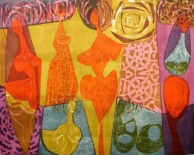 | Mini-Art | Rites of Passage - Fabric design  Skills focus: Textiles & Printing  Artist/s: (Cultural/religious textile designs) William Morris, Lucienne Day  Faith Ringgold  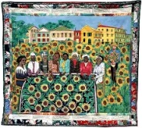  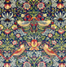    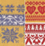 | Mini-Art

